Experiment 9

AIM: Realization of LTI system and verify it.

THEORY:
Linear time-invariant (LTI) systems are systems that are both linear and time-invariant.
Let x1(t) and x2(t) be any two signals. Suppose that the output of a system to x1(t) is y1(t) and the output of the system to x 2(t) is y2(t).
If this always implies that the output of the system to

then the system is linear and the superposition principle is said to hold.

A system is said to be time invariant if when y(t) is the output that corresponds to x(t), then for any τ , y(t − τ ) is the output that corresponds to x(t − τ ).
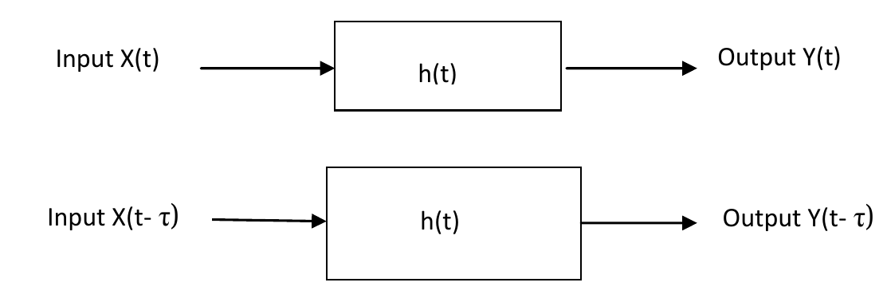
Then if input x(t) is delayed by time τ then output is also delayed by same time τ.x

=================================================================

1. Check whether the system is LTI or not. In each of the given example y(t) is an output of system and x(t) is an input of system.
- y(t) = sin(x(t))
- y(t) = log(x(t))
- y(t) = sqrt(x(t))
- y(t) = x(t)

clc;
clearvars *;
syms t;

my_tile = tiledlayout(1,2);
% sin(a_1 * x_1(t) + a_2 * x_2(t)) should be equal to
% a_1 * sin(x_1(t)) + a_2 * sin(x_2(t))

x_1 = 2 * t;
x_2 = t;
a_1 = 2;
a_2 = 1;
lhs = sin(a_1 * x_1 + a_2 * x_2);
rhs = a_1 * sin(x_1) + a_2 * sin(x_2);
nexttile(1);
fplot([lhs, rhs])
legend('sin(a_{1} x_{1}(t) + a_{2} x_{2}(t))','a_{1} sin(x_{1}(t)) + a_{2} sin(x_{2}(t))')
if lhs == rhs
fprintf("Linear, ")
else
fprintf("Non-Linear, ")
end
clearvars all -except t;

tau = 2;
x_1 = 2 * (t - tau);
lhs = sin(x_1);
rhs = sin(2 * (t - tau));
nexttile(2);
fplot([lhs, rhs])
legend('y(t - \tau)','sin(x(t - \tau))')
if lhs == rhs
fprintf("Time-Invariant System\n")
else
fprintf("Time-Variant System\n")
end
clearvars *;

OUTPUT:
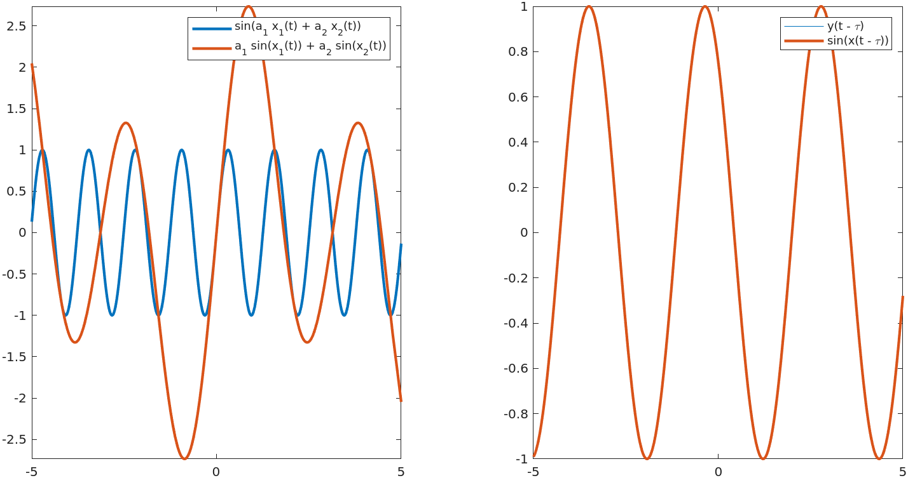

clc;
clearvars *;
syms t;

my_tile = tiledlayout(1,2);
% log(a_1 * x_1(t) + a_2 * x_2(t)) should be equal to
% a_1 * log(x_1(t)) + a_2 * log(x_2(t))

x_1 = 2 * t;
x_2 = t;
a_1 = 2;
a_2 = 1;
lhs = log(a_1 * x_1 + a_2 * x_2);
rhs = a_1 * log(x_1) + a_2 * log(x_2);
nexttile(1);
fplot([lhs, rhs])
legend('log(a_{1} x_{1}(t) + a_{2} x_{2}(t))','a_{1} log(x_{1}(t)) + a_{2} log(x_{2}(t))')
if lhs == rhs
fprintf("Linear, ")
else
fprintf("Non-Linear, ")
end
clearvars all -except t;

tau = 2;
x_1 = 2 * (t - tau);
lhs = log(x_1);
rhs = log(2 * (t - tau));
nexttile(2);
fplot([lhs, rhs])
legend('y(t - \tau)','log(x(t - \tau))')
if lhs == rhs
fprintf("Time-Invariant System\n")
else
fprintf("Time-Variant System\n")
end
clearvars *;

OUTPUT
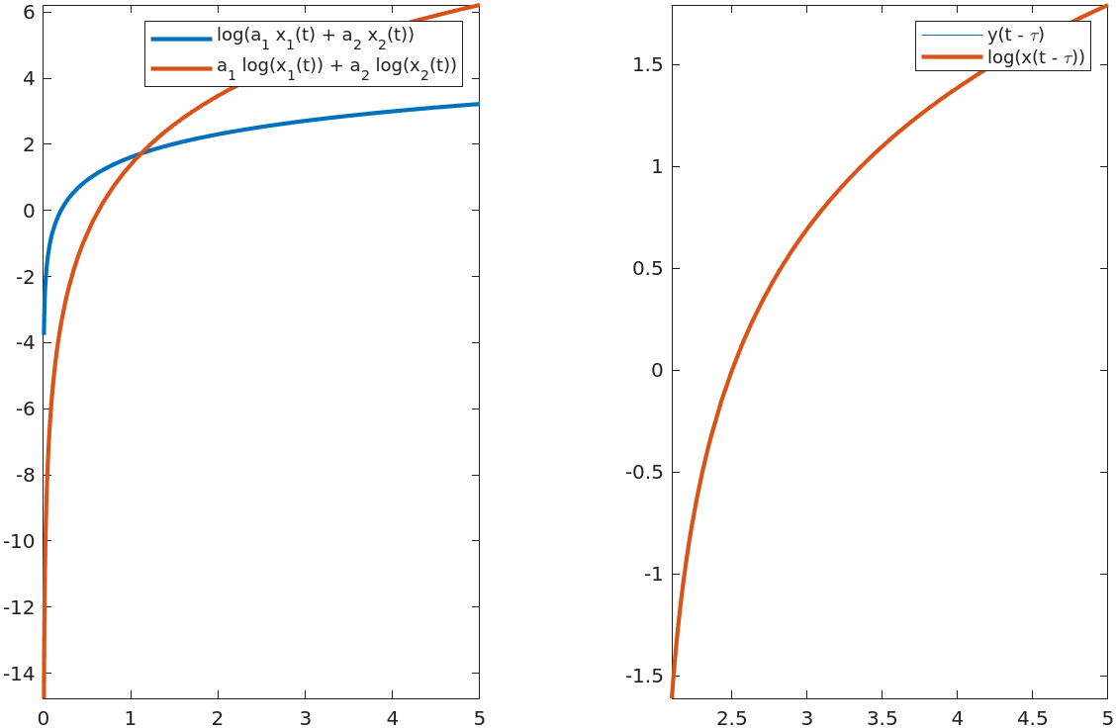

clc;
clearvars *;
syms t;

my_tile = tiledlayout(1,2);
% sqrt(a_1 * x_1(t) + a_2 * x_2(t)) should be equal to
% a_1 * sqrt(x_1(t)) + a_2 * sqrt(x_2(t))

x_1 = 2 * t;
x_2 = t;
a_1 = 2;
a_2 = 1;
lhs = sqrt(a_1 * x_1 + a_2 * x_2);
rhs = a_1 * sqrt(x_1) + a_2 * sqrt(x_2);
nexttile(1);
fplot([lhs, rhs])
legend('\surd{a_{1} x_{1}(t) + a_{2} x_{2}(t)}','a_{1} \surd{x_{1}(t)} + a_{2} \surd{x_{2}(t)}')
if lhs == rhs
fprintf("Linear, ")
else
fprintf("Non-Linear, ")
end
clearvars all -except t;

tau = 2;
x_1 = 2 * (t - tau);
lhs = sqrt(x_1);
rhs = sqrt(2 * (t - tau));
nexttile(2);
fplot([lhs, rhs])
legend('y(t - \tau)','\surd{(x(t - \tau)}')
if lhs == rhs
fprintf("Time-Invariant System\n")
else
fprintf("Time-Variant System\n")
end
clearvars *;

OUTPUT:
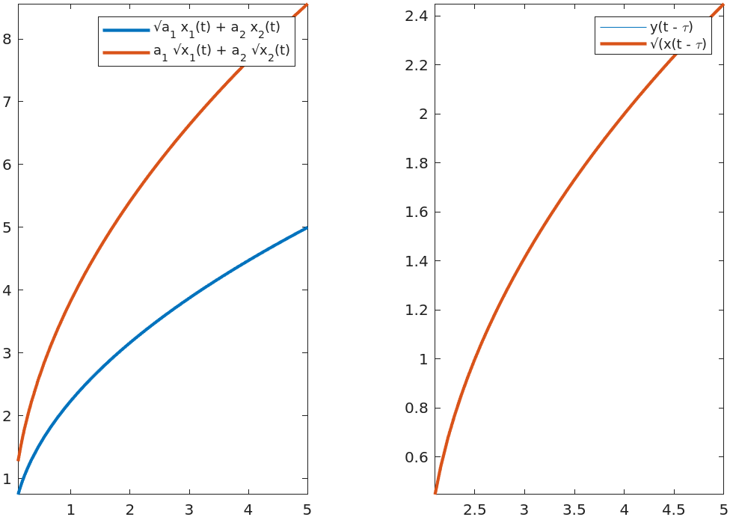

clc;
clearvars *;
syms t;

my_tile = tiledlayout(1,2);
% a_1 * x_1(t) + a_2 * x_2(t) should be equal to
% a_1 * x_1(t) + a_2 * x_2(t)

x_1 = 2 * t;
x_2 = t;
a_1 = 2;
a_2 = 1;
lhs = a_1 * x_1 + a_2 * x_2;
rhs = a_1 * x_1 + a_2 * x_2;
nexttile(1);
fplot([lhs, rhs])
legend('a_{1} x_{1}(t) + a_{2} x_{2}(t)','a_{1} x_{1}(t) + a_{2} x_{2}(t)')
if lhs == rhs
fprintf("Linear, ")
else
fprintf("Non-Linear, ")
end
clearvars all -except t;

tau = 2;
x_1 = 2 * (t - tau);
lhs = x_1;
rhs = 2 * (t - tau);
nexttile(2);
fplot([lhs, rhs])
legend('y(t - \tau)','x(t - \tau)')
if lhs == rhs
fprintf("Time-Invariant System\n")
else
fprintf("Time-Variant System\n")
end
clearvars *;
OUTPUT
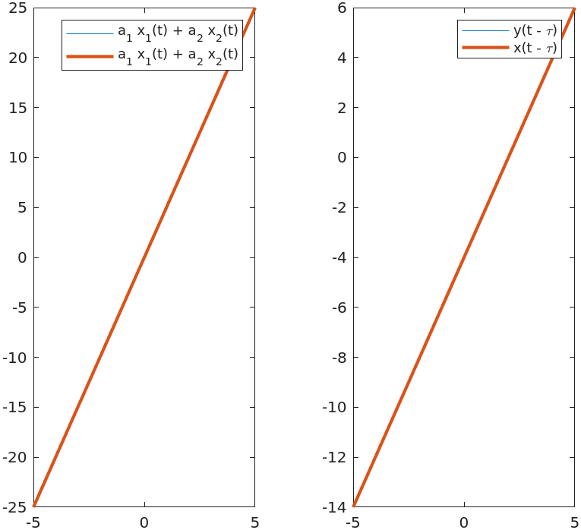
+-+-+-+-+-+-+-+-+-+-+-+-+-+-+-+-+-+-+-+-+-+-+-+-+-+-+-+-+-+-+-+-+-+-+-+-+-+-+

2. Determine and sketch the overall response h(n) of the system.
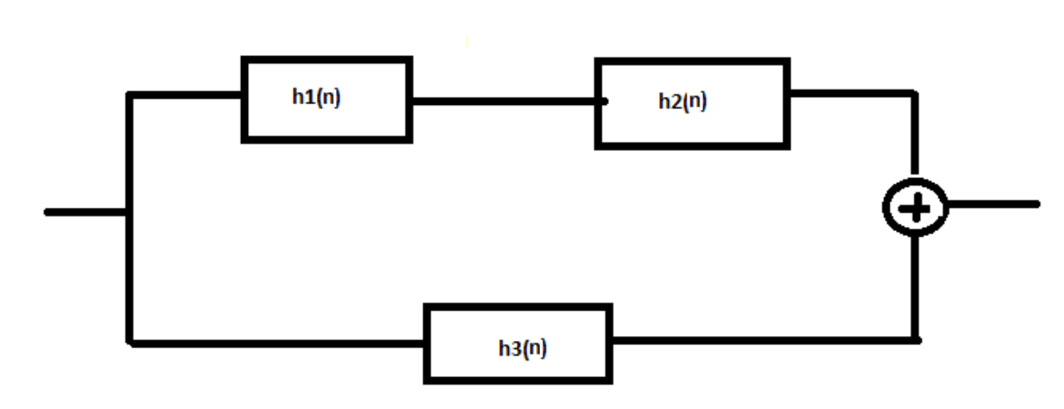
Where

tic;
clc;
clearvars *;
syms n k;
h_1 = dirac(k);
h_2 = heaviside(k - n) - heaviside(k - n - 2);
h_12_conv = int(h_1 * h_2, k, -Inf, Inf);
h_3 = dirac(n + 1);

final = h_12_conv + h_3;
fplot(final);
ylim([-0.25 1.25]);
clearvars *;
toc;

OUTPUT:
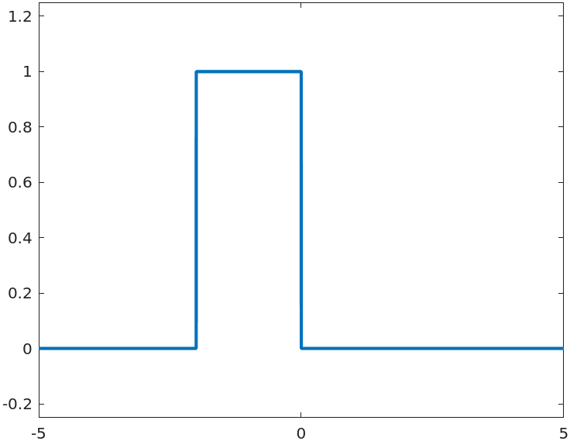

+++++++++++++++++++++++++++++++++++++++++++++++++++++++++++++++++++++++++++++

3. A continuous LTI system is characterised by the impulse response, h(t) where h(t) = u(t+2)-u(t-2). Determine the response y (t) of the system for input x(t).

tic;
clc;
clearvars *;
syms n k;
h_n = heaviside(k + 2) - heaviside(k - 2);
x_n = dirac(k - n + 2) + dirac(k - n + 1) + dirac(k - n - 1);
the_conv = int(h_n * x_n, k, -Inf, Inf);
fplot(the_conv);
ylim([-0.25 3.25]);
clearvars *;
toc;

OUTPUT:
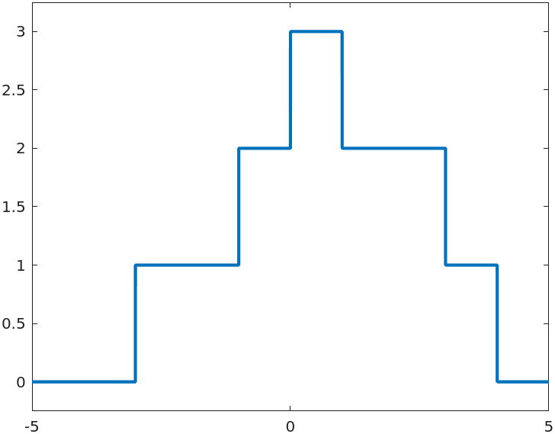

=============================================================================

RESULT: In the MATLAB experiment, we learnt to compute LTI systems and figure out if they are linear or time-invariant. The result represents the output signal formed by shifting the input signals, demonstrating the linear time-invariant system's response.

LEARNING OUTCOME: Learning Outcomes of this experiment are:
- Developing proficiency in using MATLAB for signal processing tasks.
- Gaining practical experience in convolving discrete time signals.
- Insight into how convolution affects signal characteristics.
- Real-world application of convolution in filtering and system analysis.

